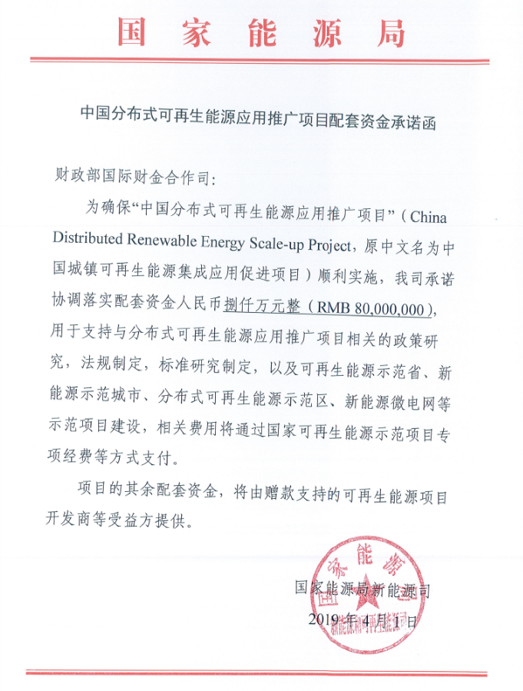

--- TRANSLATION (from original Chinese) ---

China Distributed Renewable Energy Scale Up Project
Letter of Commitment on Supporting Fund

The Department of International Fiscal and Financial Cooperation of the Ministry of Finance,
To ensure the smooth implementation of the “China Distributed Renewable Energy Scale Up Project” (Previously called China Urban Renewable Energy Integrated Application Promotion Project), our Department will coordinate and prepare a supporting fund of RMB Eighty Million Only to support the policy study, regulation formulation, and standards development, and the implementation of renewable energy city, green energy county, distributed renewable energy pilot zone, renewable energy micro-grid and other pilot projects, and related expenses will be paid as special funds (as matching grant) under the National Renewable Energy Pilot Program and through other means.
The remaining funds needed for the implementation of the captioned project will be covered by the beneficiaries who receive grant support to implement pilot projects.

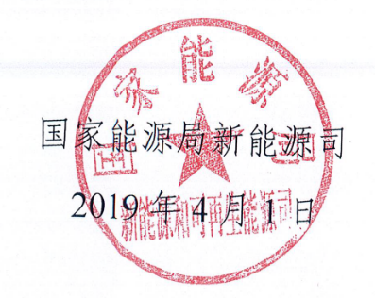
National Energy Administration
Department of New and Renewable Energy
April 1, 2019

